**Year 8 Source Analysis – Source Page**

**Source 1:** Trial by Combat in Augsburg (c. 1540)

Illustration by Bayrische Staatsbibliothek from the 16th century showing the judicial trial by combat battle between Marshal Wilhelm von Dornsberg and Theodor Haschenacker in 1409.

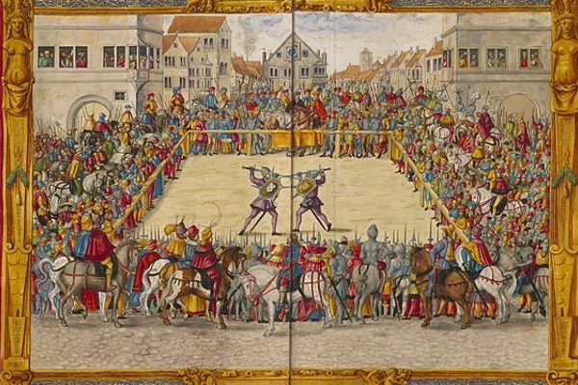Dornsberg’s sword broke early in the duel, but he proceeded to kill Haschenacker with his own sword.

**Source 2:** *A knight promises to be loyal to his king (c. 1390)*

*Ornate glass mural from the 14th Century.*

*As part of the Feudal System, Knights often had to declare fealty and offer protection to their kings in exchange for land.*

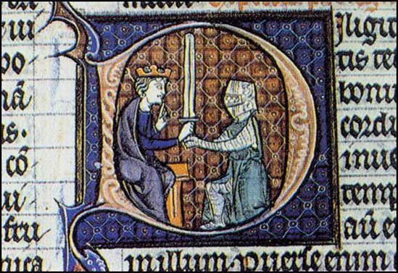

**Source 3:** *Excerpt from Pope Urban II speech (c. 1095)*

*In 1094 Pope Urban II gave a speech at the council of Claremont at the urging of the Byzantine emperor, Alexios I Komnenos.*

*Urban addressed a great crowd at the council and urged all to go to the aid of the Greeks and recover Jerusalem and Palenstine from the rule of the Muslims.*

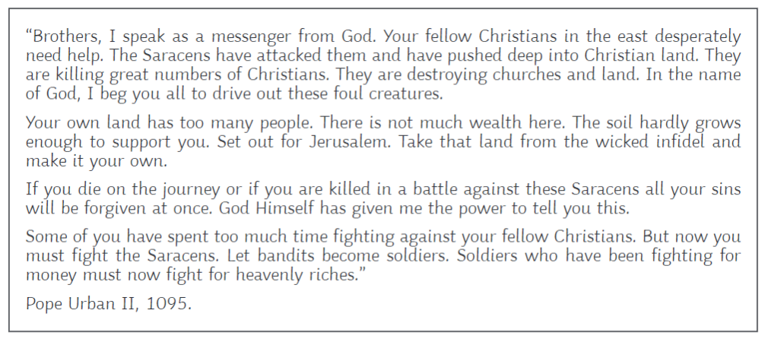

<https://sourcebooks.fordham.edu/source/urban2-5vers.asp>

**Source 4:** *Depiction of Vikings raiding a monastery (c. 793)*

*Illustration published by Hurstwic Viking-age History in the 21st Century.*

*The Vikings raid a wealthy monastery on the tidal island of Lindisfarne, off the coast of England. This is often considered the official beginning of the Viking age in England.*

